Energy Converters

Energy converters are devices which convert energy from one form into one or more different forms.

Explain how the following devices act as an energy converter:
- Engine of a car
Chemical → kinetic (movement), heat, sound, electrical
- The brakes on a car
Kinetic → sound, elastic, heat, kinetic (person)
Using electrical energy.

Electric current can transport energy to our homes, school, and places of work. The diagram below shows some electrical appliances which convert electrical energy to other forms. The exact place where the energy change occurs is shown in a circle beside each complete device. For example, the element in the radiator is drawn in the circle.

Look at the diagram and then answer the questions given below.

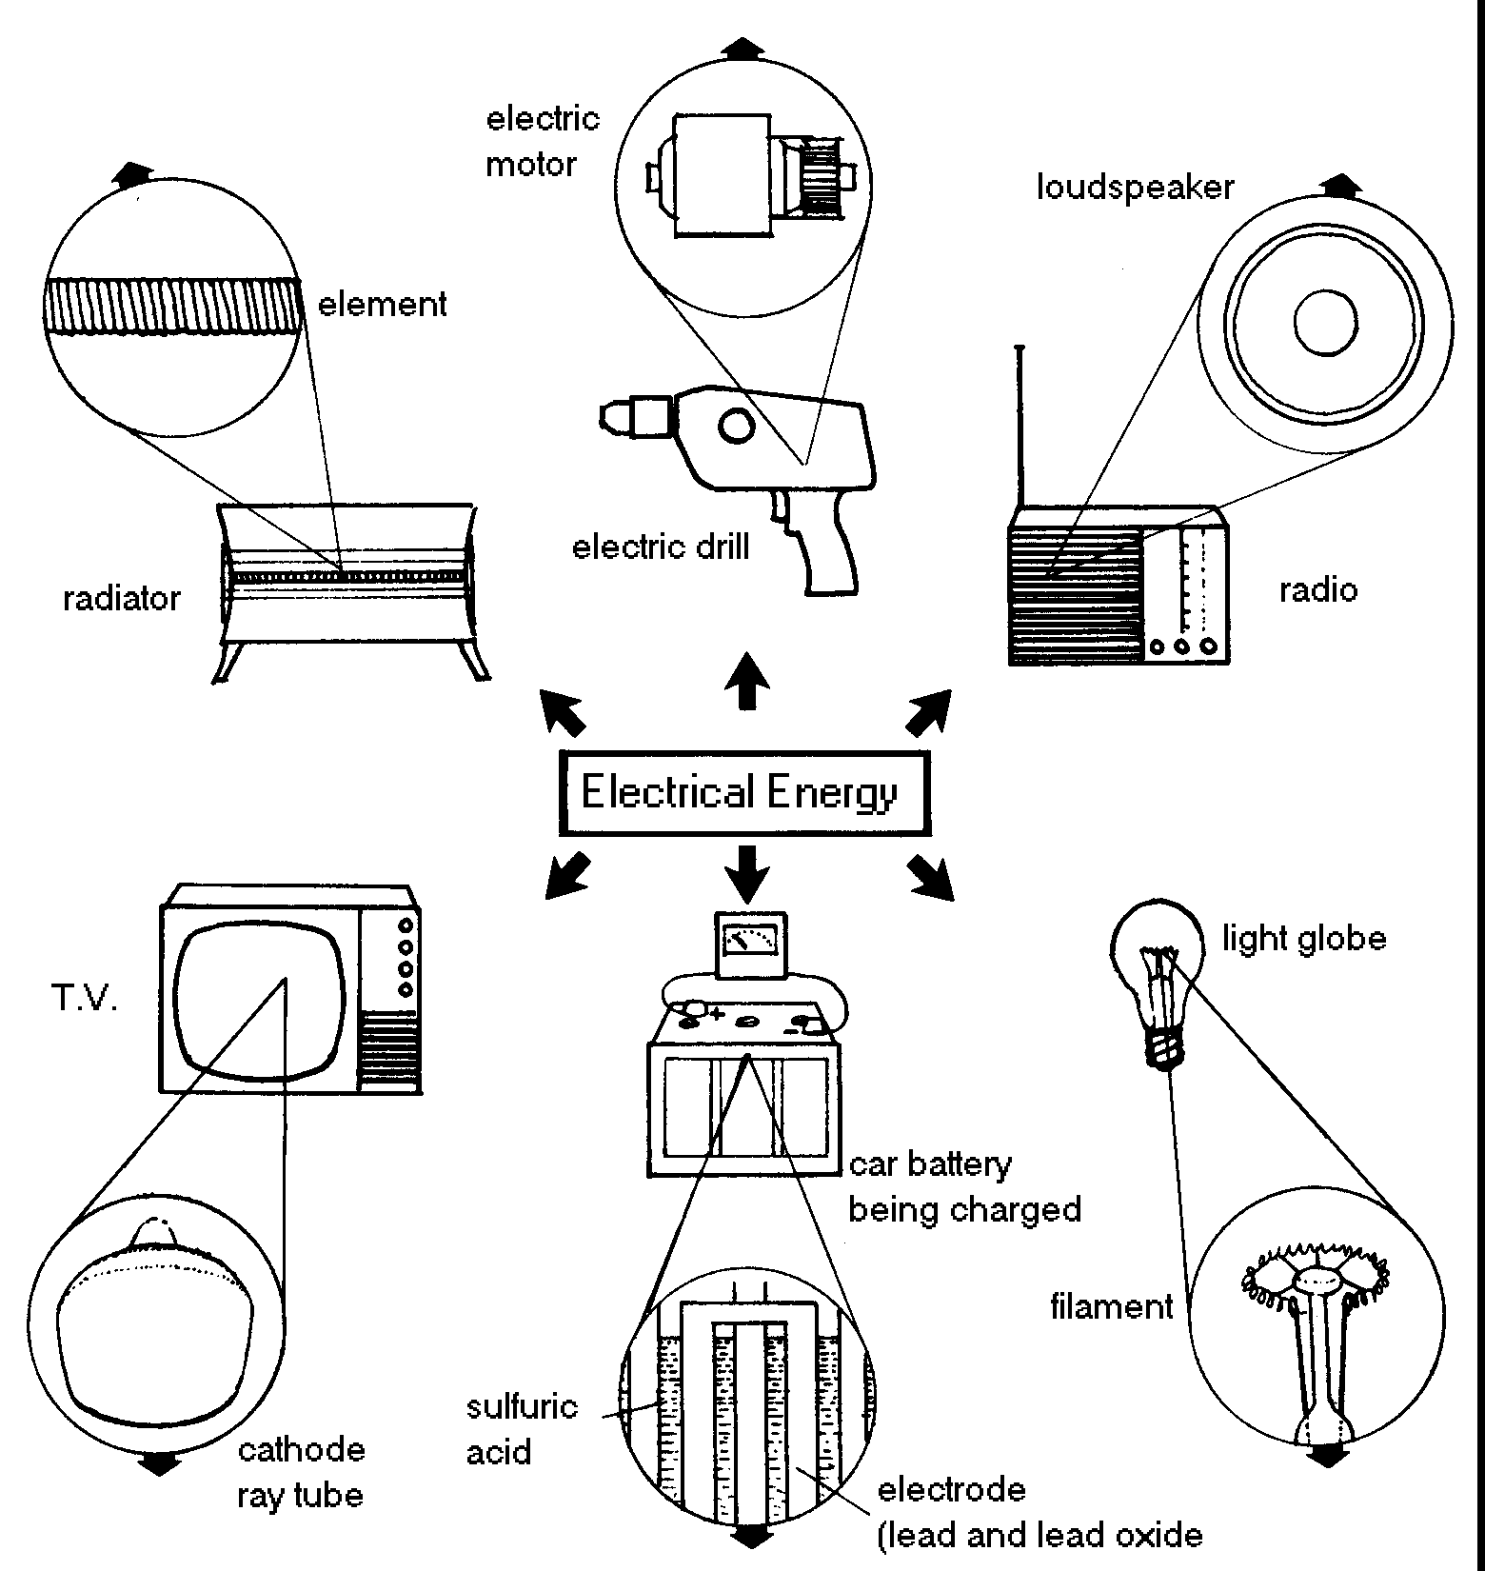

1. What do we use each of these appliances for?
a) radiator
heat
b) TV
sound and light
c) car battery
electrical, chemical
d) loudspeaker
sound

e) light globe
light

f) electric motor
movement (kinetic)

2. Give the name of an appliance that is used by us to turn electrical energy into:
a) sound energy
TV drill radio
b) heat energy
Radiator, light globe, radio, car battery, drill, TV
c) kinetic energy
drill,

3. Each device shown in the diagram changes electrical energy into other types of energy. In the boxes, write these types of energy.

4. Sometimes several types of energy come from one device. However, one type of energy comes from all the devices, whether it is needed or not! What type of energy is this?
__________________________________________________________________________________________

5. What energy changes occur in:
a) a torch ___________________________________________________________________________________________
b) gas oven
__________________________________________________________________________________________
c ) solar water heating panels ?
__________________________________________________________________________________________

6. Research the following types of electricity generation, listing the many types of energy transformation which happen during the process:
a) Solar power
b) Nuclear power
c) Solar power
d) Tidal power

